**Attribute Selector**

The [attribute] selector is used to select elements with a specified attribute.

|  |
| --- |
| <!DOCTYPE html> |
|  | <html lang="en"> |
|  | <head> |
|  | <meta charset="UTF-8"> |
|  | <meta http-equiv="X-UA-Compatible" content="IE=edge"> |
|  | <meta name="viewport" content="width=device-width, initial-scale=1.0"> |
|  | <title>Document</title> |
|  | <style> |
|  | input[type="text"],input[type="email"],input[type="password"]{ |
|  | width: 100%; |
|  | } |
|  | </style> |
|  | </head> |
|  | <body> |
|  |  |
|  | <input type="text" name="" id=""> |
|  | <input type="password" name="" id=""> |
|  | <input type="email" name="" id=""> |
|  | <input type="radio" name="" id=""> Male |
|  | <input type="radio" name="" id=""> Female |
|  |  |
|  | </body> |
|  | </html> |

Pseudo Selector

* Pseudo selector is used to give the animation and as well as the different type of classes like:

1. Link
2. Visited
3. Active
4. Focus
5. Hover

|  |  |  |
| --- | --- | --- |
| [:focus](https://www.w3schools.com/cssref/sel_focus.asp) | input:focus | Selects the <input> element that has focus |
| [:hover](https://www.w3schools.com/cssref/sel_hover.asp) | a:hover | Selects links on mouse over |
| [:link](https://www.w3schools.com/cssref/sel_link.asp) | a:link | Selects all unvisited links |
| :active | a:active | Selects when mouse click is press. |
| :focus | a:focus | The :focus selector is used to select the element that has focus. |

Pseudo Element

1. First Letter

* The ::first-letter pseudo-element is used to add a special style to the first letter of a text.

<!DOCTYPE html>

<html>

<head>

<style>

p::first-letter {

color: #ff0000;

font-size: xx-large;

}

</style>

</head>

<body>

<p>You can use the ::first-letter pseudo-element to add a special effect to the first character of a text!</p>

</body>

</html>

1. First Line

* The ::first-line pseudo-element is used to add a special style to the first line of a text.

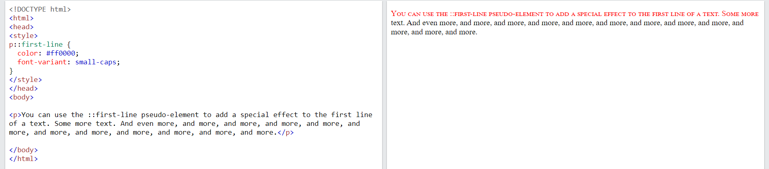

1. Before

* The ::before pseudo-element can be used to insert some content before the content of an element.

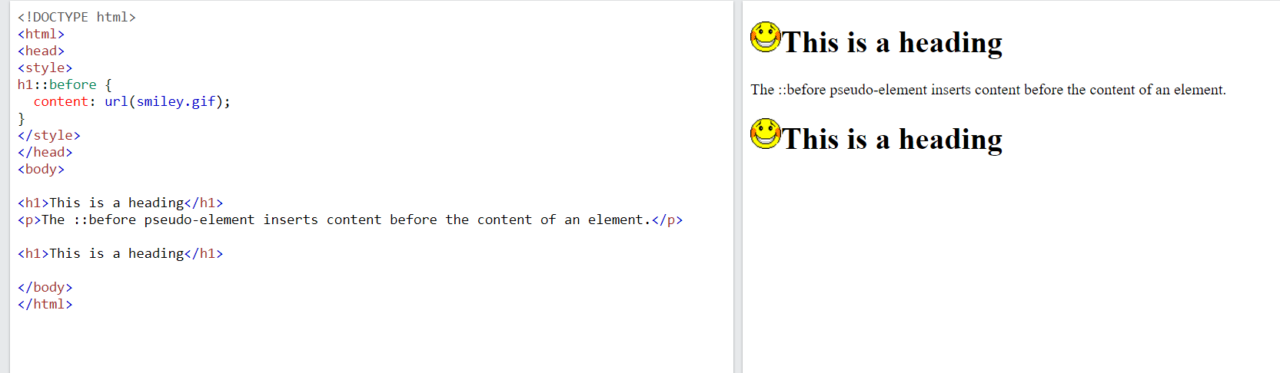

1. After

* The ::after pseudo-element can be used to insert some content after the content of an element.

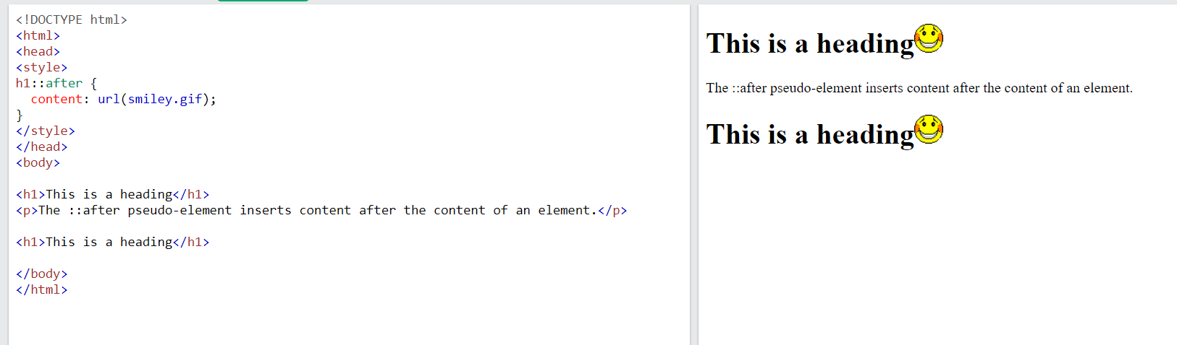

1. nth child

* If we want to give the selector matches every element that is the child of parent then we use nth child.

Ex

